Review 2

Calorie BURNER APP

TEAM Members:

Abishek arjun

Harsha

Sreenithya

Ojas

Abstract:

An app to track the fitness of the body, by managing the amount of calories taken by the person depending upon the consumed food items. User is made to fix a daily limit .Then his progress is displayed as he updates about his nutritional intakes in the app.

Software’s used :

Android studio.

Flow chart:

Add calories

Main activity

Burn calories

Fix the daily-limit

Screen shot :

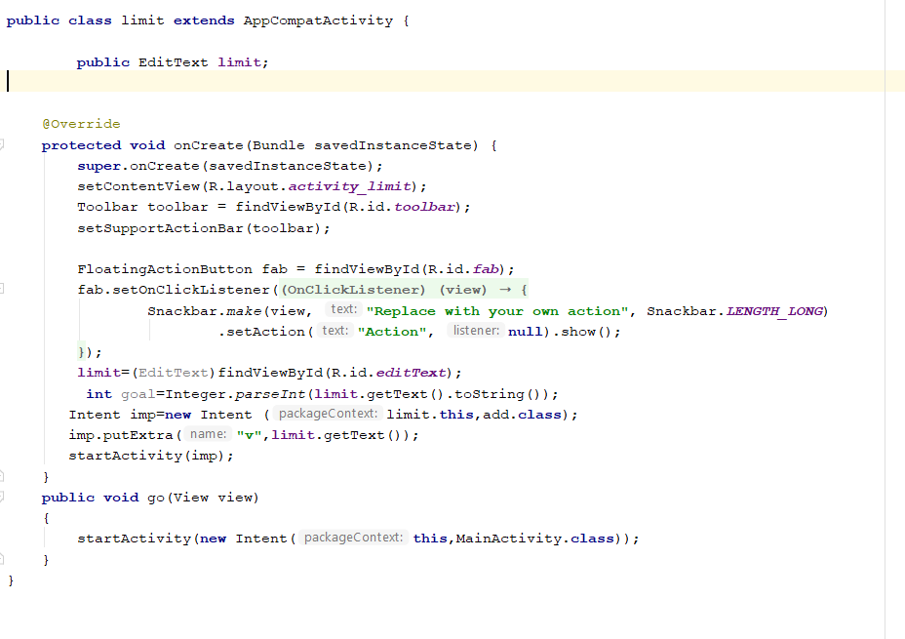

Code for setting daily limit, from this activity the daily limit value is passed to other activity

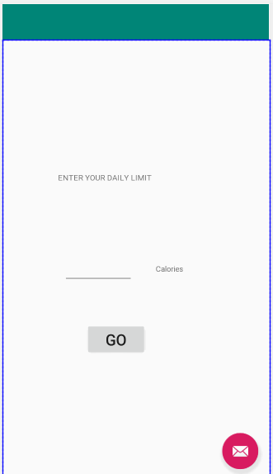

UI- Set daily limit

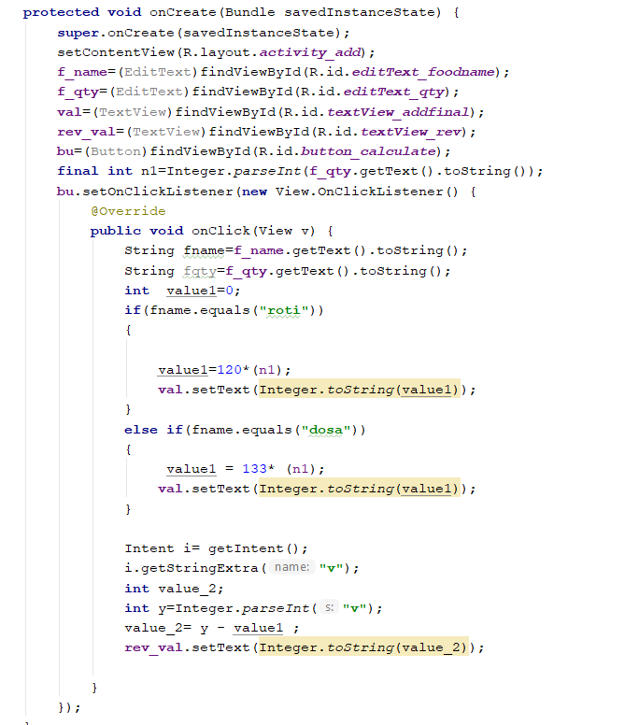

Code- calculating calories(currently limited no.of food item are include)

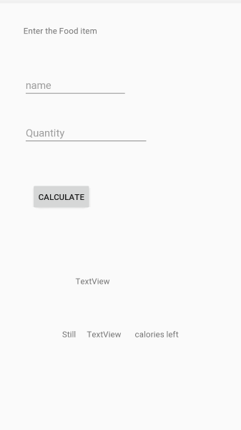

UI- adding calories

Logic:

4 simple activities are created, 3 buttons are initialised in the main activity, then 3 on click functions are defined in the xml file of main activity, then on clicking respective buttons user is directed to respective activities.

Updates:

To set the daily limit, a seek bar is placed and the value which is obtained from the seek bar is passed, to adding calories and burning calories activity.

A new activity called “status” is initialised with a circular progress bar, to see the calories burnt.

In the burn activity, the step tracker has been used at the end of the calories burnt is calculated based on the basis of steps taken.

UI for step tracking

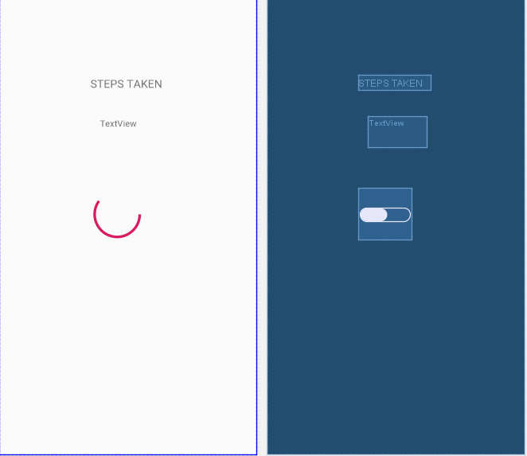

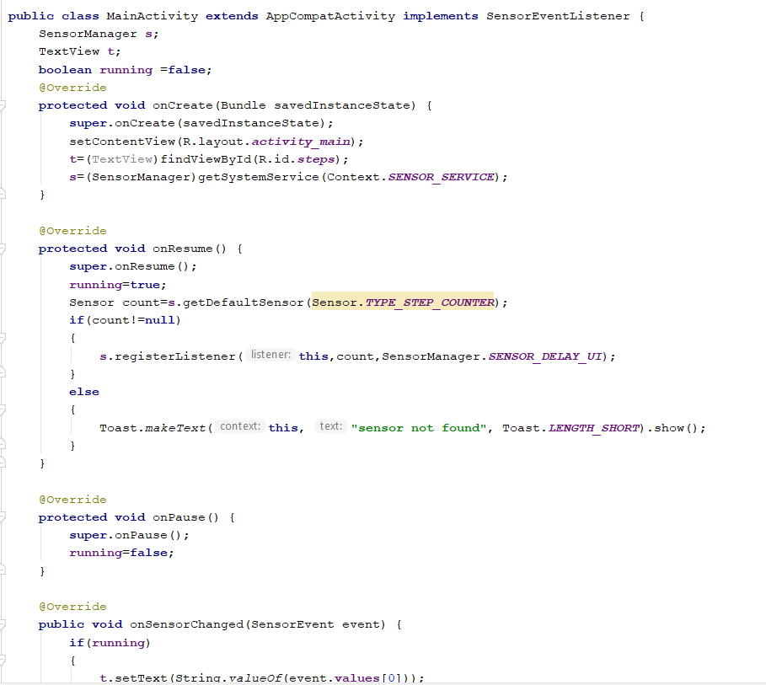

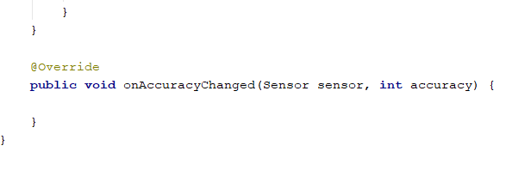

UI FOR SETTING THE DAILY LIMIT

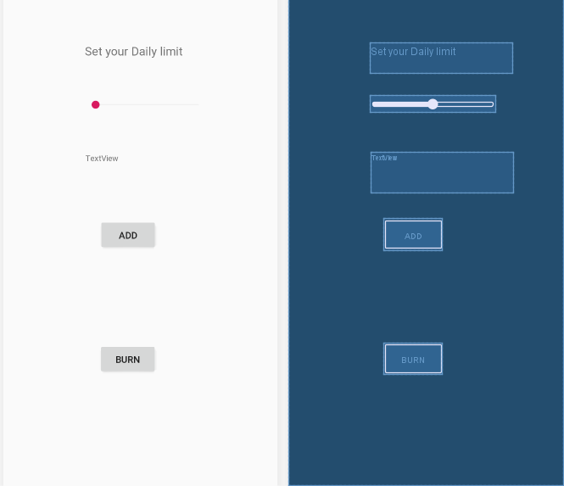

CODE FOR SEEK-BAR :

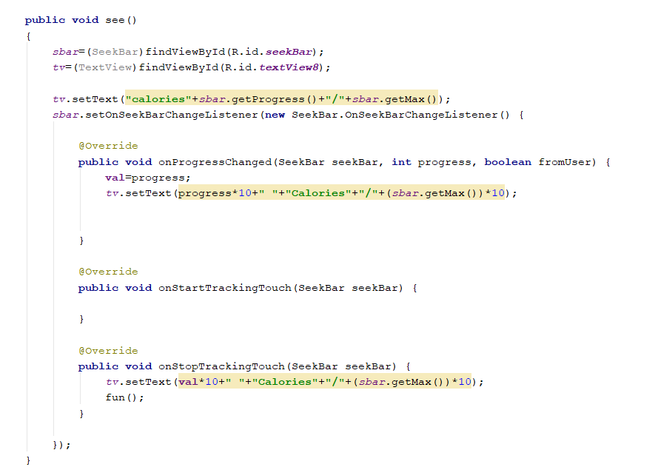

CODE FOR Transfer of variables (sending):

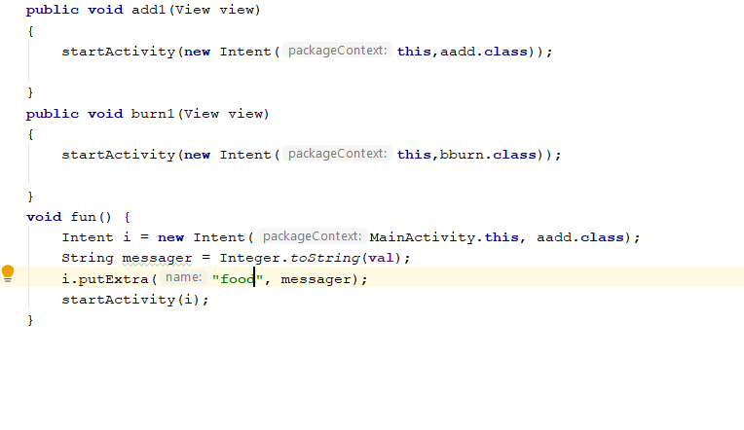

Receiving the variable:

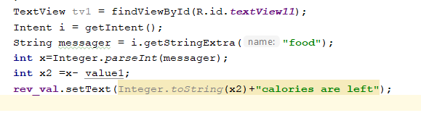

UI For Burning the calories:

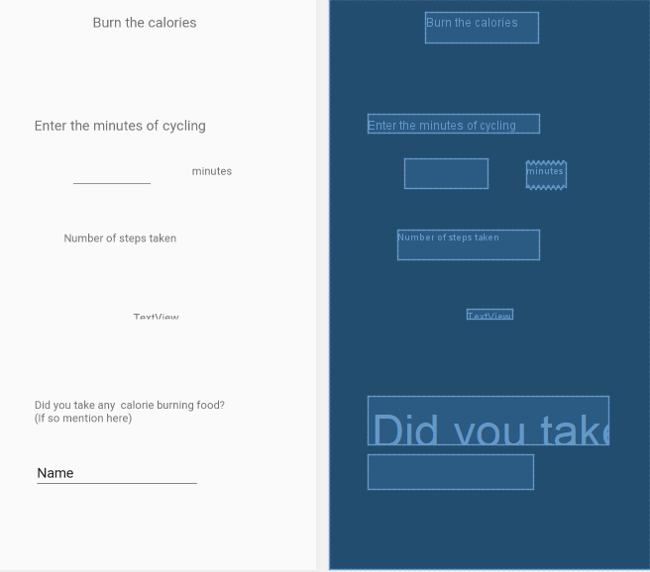

From here with the values entered by the user calories burnt are calculated.